Norfolk SEN Network
Celebration event!
Come and celebrate 35 years of Norfolk SEN Network
With NORWICH BARBERSHOP SINGERS – FINE CITY CHORUS
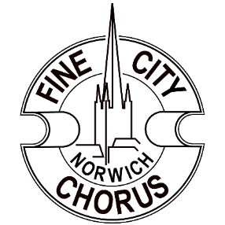
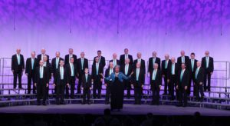

Friday 28th October 2022 - Starting 7.30pm
Ticket only: £10 (includes buffet)

Belvedere Community Centre, Belvoir Street, Norwich (entrance near Old Palace Road/Heigham Road junction on Dereham Road)

Contact: NSENN, 62 Catton Chase, NR6 7AS, or Tel: 01603-300178 between 9am and 12 noon for tickets!

